**EXPERIMENT-2**

**TUNED AMPLIFIER**

(Single Tuned Amplifier)

-----------------------------------------------------------------------------------------------------------------------------------------------------------------------------------------------------------------------------------------------------------------------------------------------------------------------------------------------

To design and plot the frequency response of a single tuned amplifier.

1. **Aim:**
2. **Objectives:**

**1.** Design a single tuned amplifier for a given specifications.

2. Simulate the designated single tuned amplifier.

3. Develop the hardware for designated amplifier.

4. Obtain the frequency response for designated amplifier.

5. Compare the software and hardware results that are obtained.

1. **Specification:** Operating Frequency of the Circuit = 10 kHz.
2. Silicon-NPN-transistor BC107
3. Resistors: 18.3kΩ,6.8kΩ,1kΩ
4. Inductors: 3mH
5. Capacitors: 0.1µF,10µF,100µF
6. CRO
7. Function Generator
8. Bread board
9. **Hardware:**
10. **Theory:**

**About Tuned Amplifier:**

Tuned Amplifiers are high frequency circuits designed to have a very narrow bandwidth and a voltage gain that peaks at a particular frequency. To produce these characteristics the amplifier uses a resonant parallel LC circuit (or tank circuit) as a BJT Collector load, this gives the amplifier a high voltage gain at the resonant frequency of the tank circuit.

A single tuned amplifier consists of only one LC section as a load.

A double-tuned amplifier is a type of radio frequency (RF) amplifier that utilizes two resonant circuits or tuned circuits to achieve narrowband amplification. It is commonly used in RF and microwave applications where selectivity and high gain are essential.

A stagger-tuned amplifier is a type of radio frequency (RF) amplifier circuit designed to provide selective amplification of signals within a certain frequency range. It consists of multiple amplifier stages, each tuned to amplify a specific range of frequencies. These stages are staggered in frequency.

1. **Procedure:**
2. Connect the circuit as per the circuit diagram
3. Apply 10m with 52KHz frequency using function generator{Software}

Apply 100m with 1KHz initially, slowly increase the frequency of Input Signal.

1. Observe the output in CRO.
2. Note output and frequency for max Amplitude in Observation Table.
3. Plot Frequency Response from Observations.
4. **Design:**

C=0.1µF, L~=3mH, = 10KHz

C=0.1µF, L~=30µH, = 100KHz

1. **Simulation Observations:**
2. **Single Tuned Amplifier:**

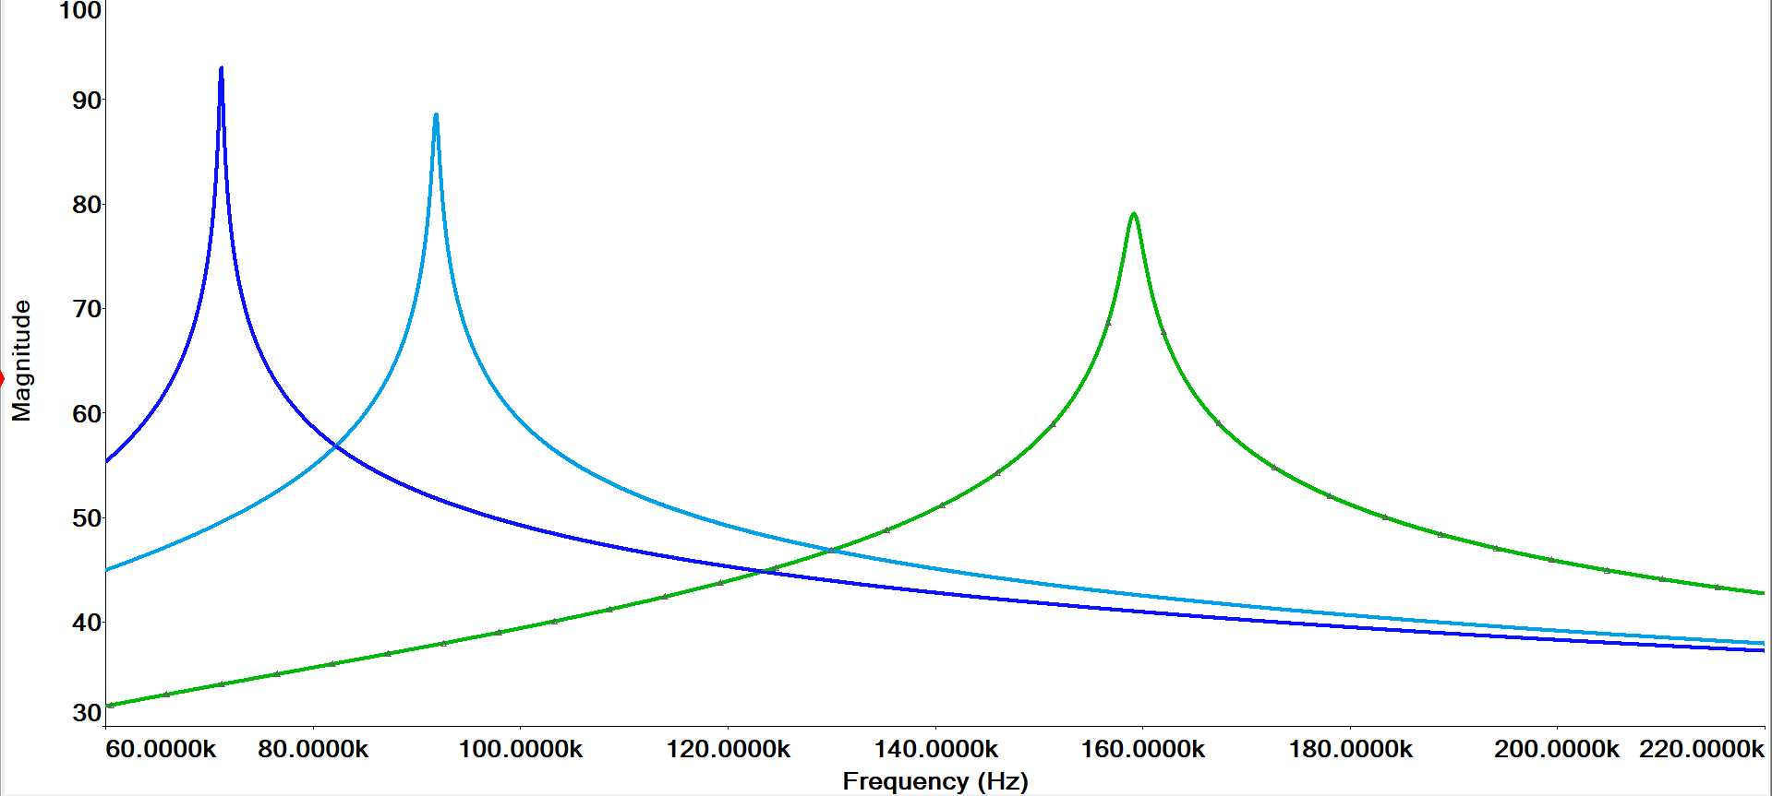

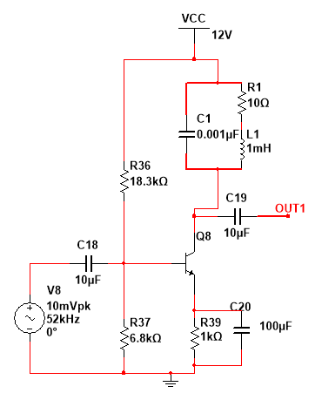

**For L=1mH**

**Figure 1. Frequency Response of Single Tuned Amplifier**

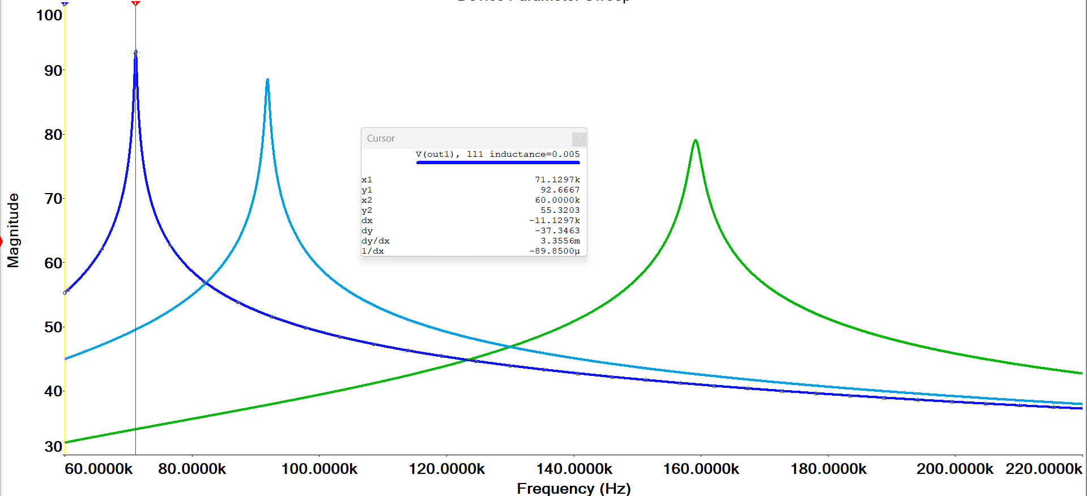

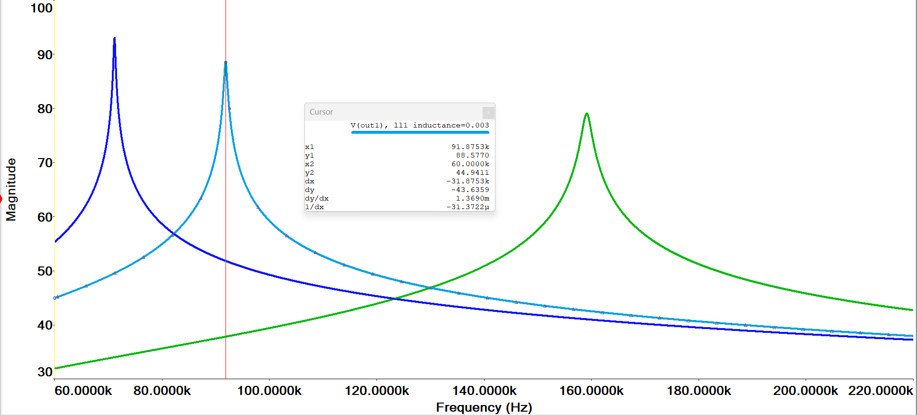

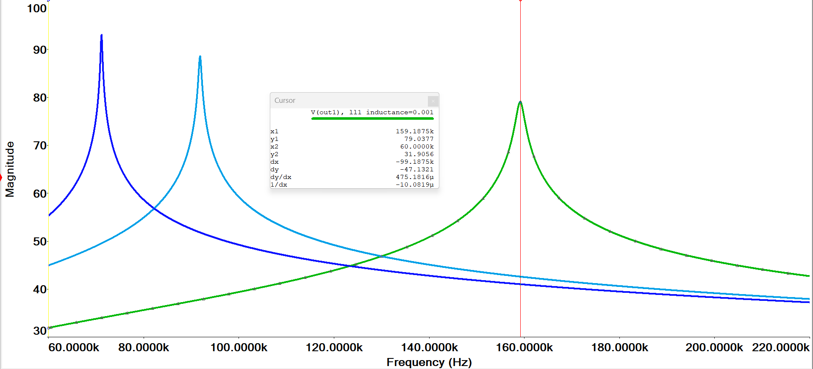

**Figure 4. =5mH**

**Figure 3. =3mH**

**Figure 2. =1mH**

**Conclusion:**From the theoretical calculations, we can observe that as the inductance, increases from 1mH to 5mH the resonant frequency is decreasing. Hence the circuit offers good selectivity as the resonant frequency is limiting. Hence if we want to decrease the resonant frequency we can increase the inductance values if we want to increase resonant frequency we can simply increase it by decreasing inductance value.

1. **Double Tuned Amplifier:**

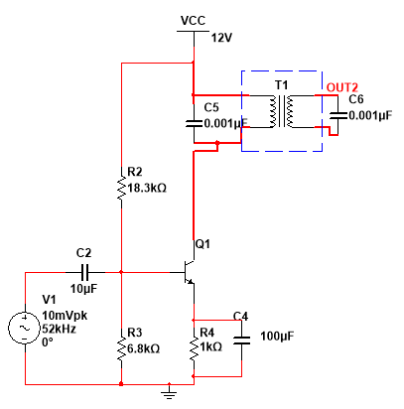

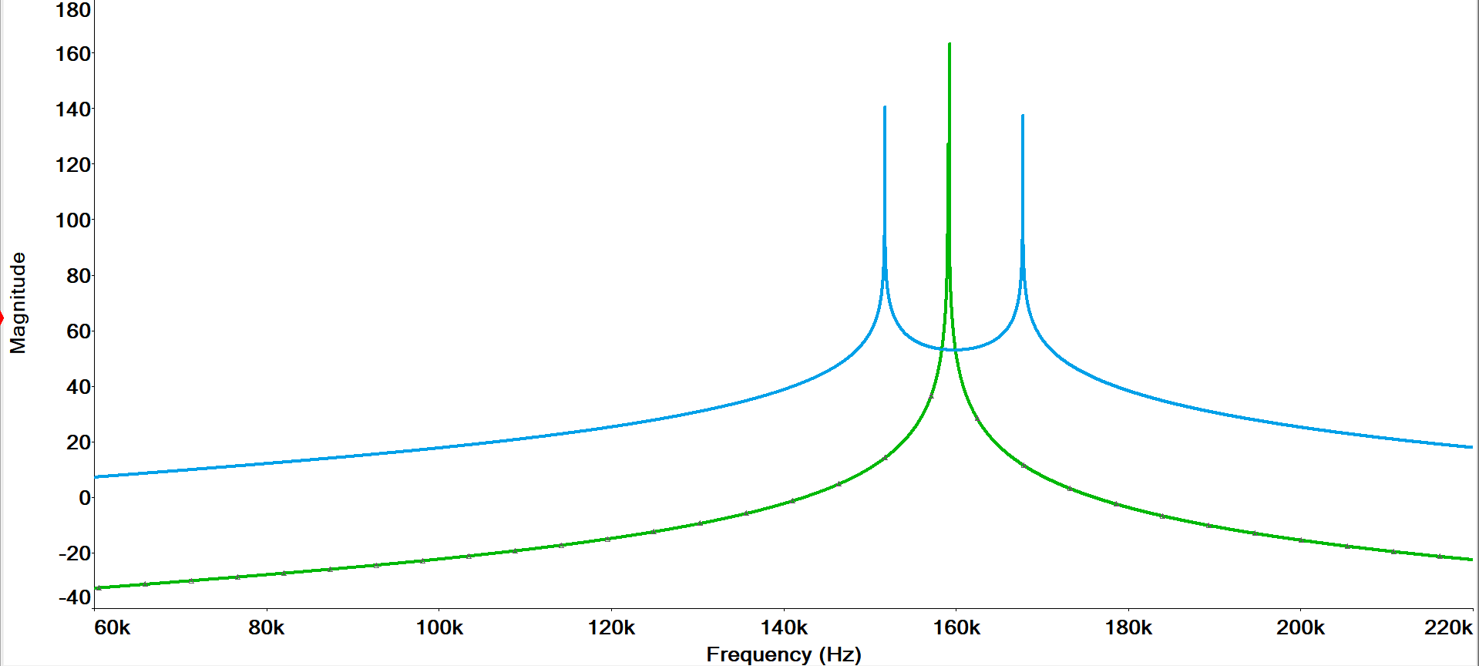

Bandwidth=k*f

**Figure 5. Frequency Response of Double Tuned Amplifier**

A double-tuned amplifier is an electronic amplifier that employs two tuned circuits to selectively amplify signals at two distinct frequencies. It exhibits a narrowband frequency response, with high gain and selectivity within the range determined by the tuning frequencies of the two resonant circuits. The response outside this range gradually attenuated. The use of two tuned circuits in a double-tuned amplifier allows for more precise tuning and better rejection of unwanted frequencies.

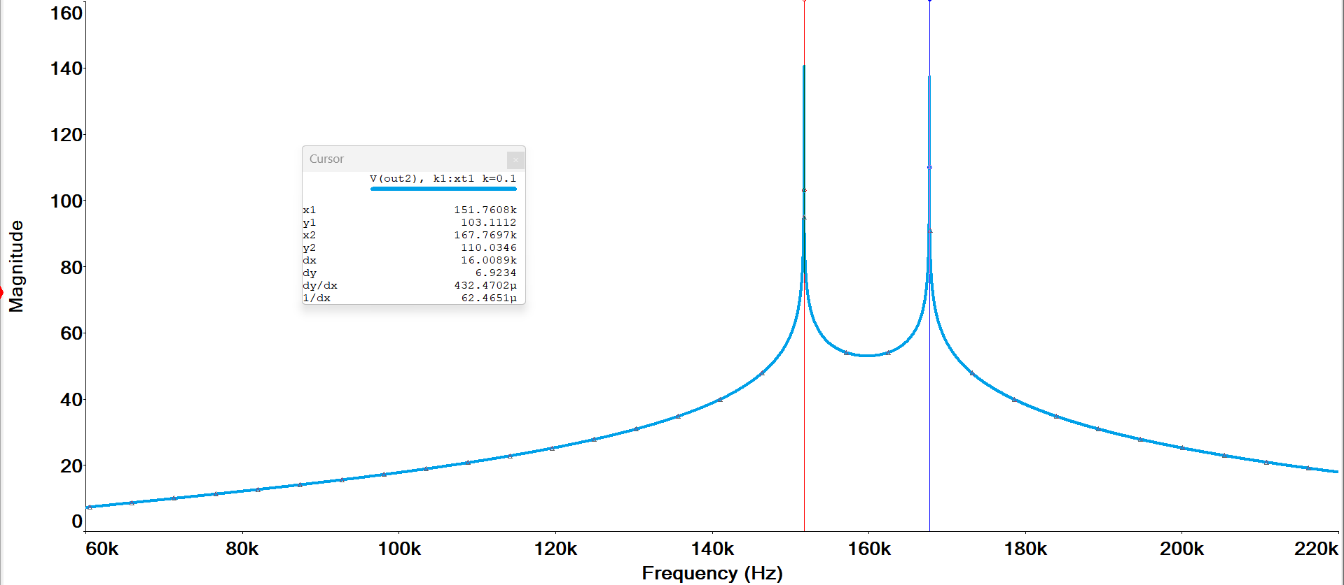

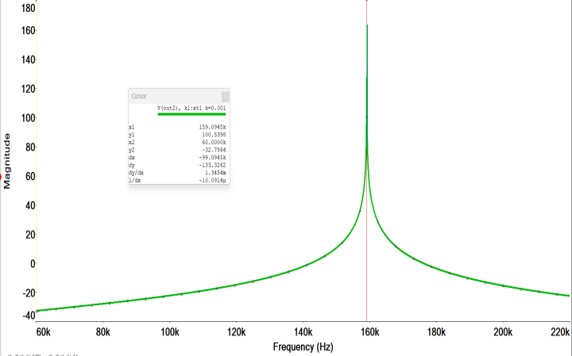

**Figure 7. k=0.1**

**Figure 6. k=0.01**

**Bandwidth and Q-Factor:**

The bandwidth and selectivity of the double-tuned amplifier are determined by the Q-factor of each tuned circuit.

Q-factor=

Bandwidth(BW) = k*

Where k=coefficient of coupling.

**Conclusion:**

It offers better selectivity and bandwidth compared to single tuned amplifiers. The tuned circuits provide additional tuning stages,which improve the amplifier’s ability to reject unwanted frequencies while amplifying the desired ones.

K=0.001->Loose Coupling, K=0.1->Tight Coupling.

1. **Stagger Tuned Amplifier:**

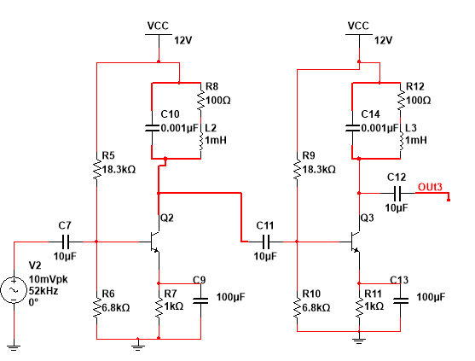

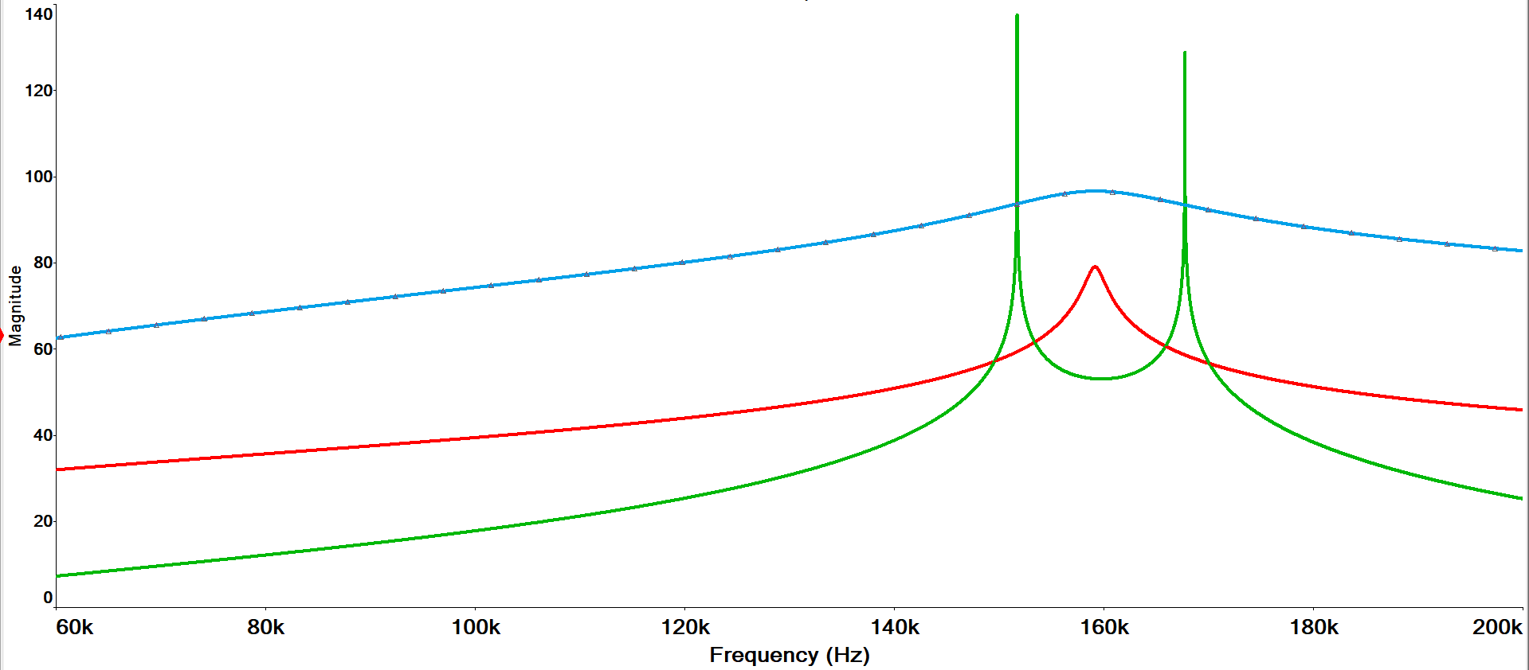

**Figure 8. Frequency Response of Stagger Tuned Amplifier**

**Conclusion:**

This staggering of resonant frequencies helps to mitigate the effect of tuning component tolerances and improves the flatness of the frequency response. Stagger-tuned amplifiers offer improved performance over double-tuned amplifiers in terms of frequency response linearity and stability.

**Frequency Response:**

**At L=3mH:**

|  |  |  |  |
| --- | --- | --- | --- |
| FREQUENCY(Hz) | INPUT(V) | OUTPUT(V) | GAIN in dB |
| 1K | 50m | 169m | 24.35 |
| 2K | 50m | 221m | 29.72 |
| 3K | 50m | 362m | 39.59 |
| 4K | 50m | 342m | 38.45 |
| 5K | 50m | 460m | 44.38 |
| 8K | 50m | 1.29 | 65 |
| 9.1K | 50m | 4 | 87.64 |
| **9.79k** | **50m** | **6.6** | **97.65** |
| 10k | 50m | 3.5 | 84.96 |
| 13k | 50m | 1 | 59.91 |
| 16k | 50m | 800m | 55.45 |
| 18k | 50m | 600m | 49.69 |
| 20k | 50m | 500m | 46.05 |

**At L=30uH:**

|  |  |  |  |
| --- | --- | --- | --- |
| FREQUENCY(Hz) | INPUT(V) | OUTPUT(V) | GAIN in dB |
| 90K | 50m | 480m | 45.23 |
| **92K** | **50m** | **1.15** | **62.7** |
| 93K | 50m | 563m | 48.42 |
| 95K | 50m | 430m | 43.03 |
| 100K | 50m | 310m | 36.49 |
| 102K | 50m | 275m | 34.09 |

**Result:**

|  |  |
| --- | --- |
| RESONATING FREQUENCY  (single tuned amplifier(L=3mH) | |
| Theoretical | 9.19 kHz |
| Practical | 9.529 kHz |

|  |  |
| --- | --- |
| RESONATING FREQUENCY  (single tuned amplifier(L=30mH) | |
| Theoretical | 91.9 kHz |
| Practical | 92.5 kHz |

Signature of the Faculty